Using Gemini, an amateur radio net control manager has been created to support operations while online or offline. Its operation is detailed in this user guide.
This program requires Python 3.8 or newer and the PyQt6 and openpyxl libraries to run. All other program dependencies are native to Python. Alternatively, a Windows .exe file is planned. Macintosh and Linux support is available by using the .py files.
Section 1 – The Profile Selector

Upon launching the program, users will be prompted to select a net profile. This screen is also visible by selecting F6 on the keyboard if the wrong net profile is loaded. Note that if a net is active when selecting a new profile, the current net’s data will be dumped and a net control operator will need to rebuild the net.

Net profiles are stored in Net Manager’s working directory in JSON format; the program automatically reads these for ease of use and customization by the user. Profiles can be created and edited inside the program. If the program has no profiles, users will be prompted to create one using the profile editor, covered in another section.

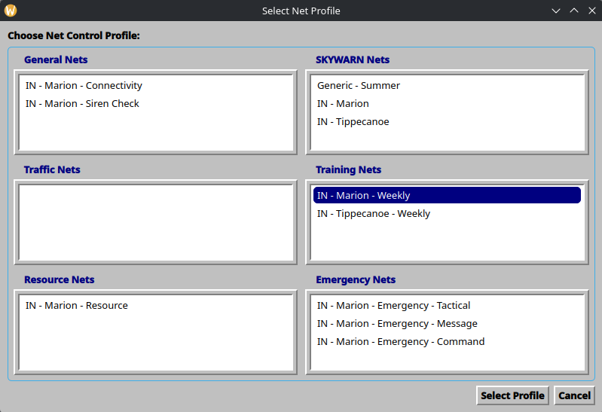

Use this screen to select from the list of available profiles.

- Select Profile – this loads the selected profile and its custom options (status badging, online status trigger, traffic and station options, etc.)
- Cancel – loads the default profile

Profiles that say [LOCKED] require user credentials to open. See your EC for login details.

Section 2 – The Login Screen

This screen launches when a net profile is selected.

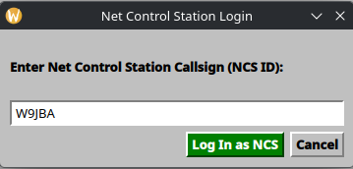

This screen allows a net control operator to enter their callsign. This is used to display the current net control station to multiple users of the same session.

- Log In as NCS – sets the net control station in the Net Control badge on the main screen, as well as for online badging purposes.
- Cancel – sets the default NCS value. This is useful for testing the program.

Continued on next page

Section 3 – The Main Screen

The main screen is separated into six zones: the status bar, the script pane, the station management pane, the net traffic pane (known as the Spotter Reports pane if a Skywarn net profile is loaded), the live net activity log, and the parent controls bar.

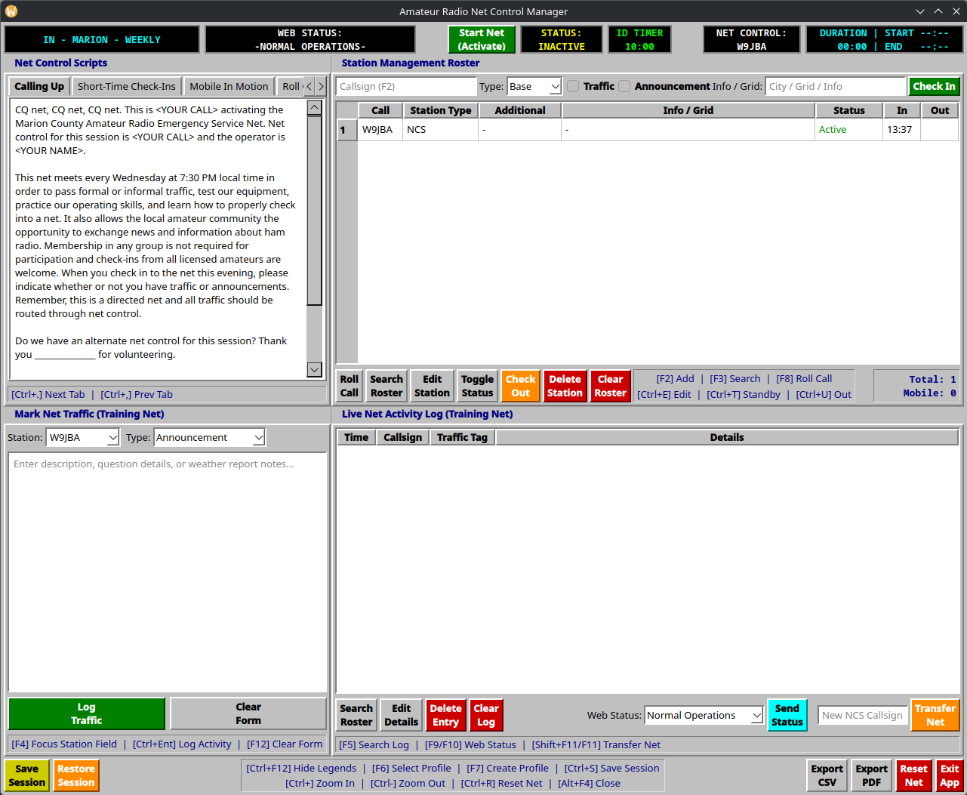

Zone One – Status Bar (Internet Status Editable)

This is displayed at the top of the program’s main screen.

From left to right:

- Profile Badge – displays the selected profile
- Web Status Badge – when API syncing is enabled, this will show the current operations status displayed on a Web site. These can be controlled from the app, and are customizable. Currently this is restricted to Marion County, IN ARES.
- Start Net (Activate) Button – triggers a net to begin. This also triggers the ID timer to count down.
- Status Badge – different from the web status badge, this only shows statuses used on air. These are customizable, including text and background coloring.
- ID Timer – when a net is active, this will trigger a 10 minute timer for the net control station to ID. When time reaches zero, the timer flashes to attract attention. Clicking this will reset the timer and restart the countdown.
- Net Control Badge – displays the callsign of the net control operator currently logged in or in control of the net. This is controlled both by the login screen and the net transfer function in the net activity log.
  - Times Badge – this static badge displays the duration of the net in HH:MM format, as well as the start and end times of the net in HH:MM format on a 24-hour clock.

It is worth noting that this layout is only applicable to profiles that have web status badging enabled.

Zone One – Status Bar (Offline)

This is displayed at the top of the program’s main screen. Note the rearranging of the offline net status indicator and the Start Net button.

From left to right:

- Profile Badge – displays the selected profile
- Status Badge – different from the web status badge, this only shows statuses used on air. These are customizable, including text and background coloring.
- Start Net (Activate) Button – triggers a net to begin. This also begins triggers the ID timer to count down.
- ID Timer – when a net is active, a timer counts down from 10 minutes to prompt the net control station to identify themselves, in compliance with FCC rules. When time reaches zero, the timer flashes to attract attention. Clicking this will reset the timer and restart the countdown.
- Net Control Badge – displays the callsign of the net control operator currently logged in or in control of the net. This is controlled both by the login screen and the net transfer function in the net activity log.
- Times Badge – this static badge displays the duration of the net in HH:MM format, as well as the start and end times of the net in HH:MM format on a 24-hour clock.

It is worth noting that this layout is only applicable to profiles that have web status badging disabled.

Zone Two – Net Control Scripts

This pane shows the scripts for the net. Users can break them up however they prefer in the profile editor.

This pane is split into tabs, with hotkeys to switch between the tabs. Ctrl+< switches to the previous tab, and Ctrl+> switches to the next tab.

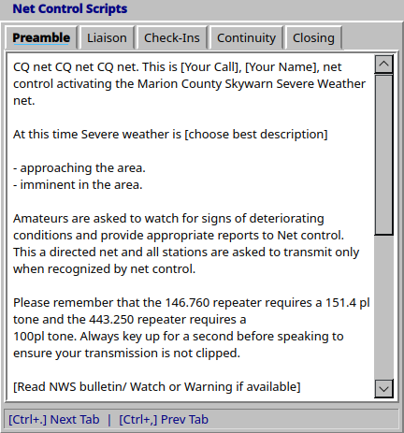

Continued on next page
Zone Three – Station Management (Skywarn)

Net control operators can manage the stations checked into their net using this screen. It is split into three sub-zones: the station entry bar, the editable station roster, and the controls bar. There are hotkeys assigned to the various functions to allow mouseless operation, such as in deployments where portable, space-saving operations render carrying a mouse unusable.

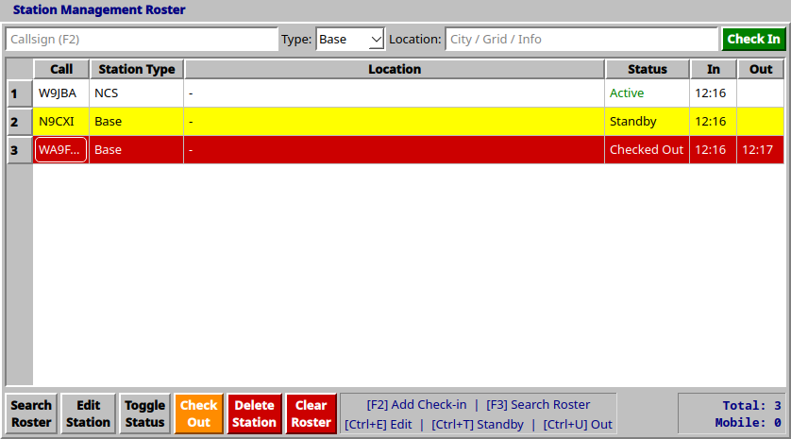

Subzone One – Station Entry Bar

This is used to enter checked-in stations to the roster.

- Callsign entry field (F2) – enter a station’s callsign here. If the characters entered match a callsign in a directory of known stations that have previously checked into nets ran by this program, a dropdown will appear allowing an operator to select that call.
- Type dropdown – allows the station type (base, portable, mobile, etc.) to be selected.
- Location – allows a station’s location to be entered if needed for the net.
- Check In (Enter) – checks a station into the net and sends it to the roster.

Subzone 2 – Editable Station Roster

As stations are checked in, they will appear in this table. Information presented here in Skywarn nets is callsign, station type, location, station status, and check-in and check-out times.

Stations will be automatically colored according to their status:

White background, green Active cell: station is active or has not indicated they have stepped away from the net.

Yellow background: station has stepped away and Net Control has toggled them to standby mode

Red background, white text: station has checked out and has been toggled as such by Net Control.

Subzone 3 – Controls Bar

This subzone is used to work stations as they check in and call with traffic.

- Search Roster (F3) – opens a search window that allows a station to be entered and then highlighted on the roster.
- Edit Station (Ctrl+E) – once a station is selected by either the mouse or the hotkey window, this opens an edit window to edit the details taken in the check-in bar such as location and station type.
- Toggle Status (Ctrl+T) – toggles a station into standby or active mode
- Check Out (Ctrl+U) – toggles a station to check out.
- Delete Station (Del) – prompts a confirmation to delete a selected station, then deletes them
- Clear Roster – prompts a confirmation to clear the roster, then erases all checked in stations
- Hotkeys legend
- Station counter – displays total number of checked in stations and total number of mobile stations

Zone Three – Station Management (Non-Skywarn)

Net control operators can manage the stations checked into their net using this screen. It is split into three sub-zones: the station entry bar, the editable station roster, and the controls bar. There are hotkeys assigned to the various functions to allow mouseless operation, such as in deployments where portable, space-saving operations render carrying a mouse unusable.

Continued on next page
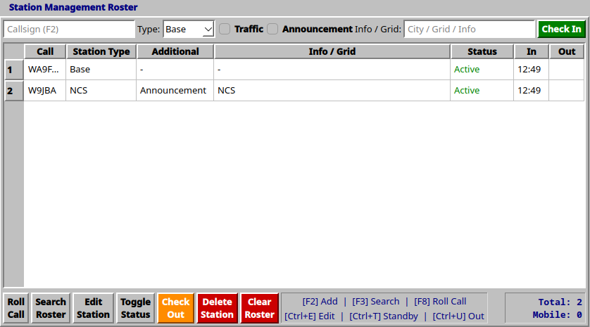

Subzone One – Station Entry Bar

This is used to enter checked-in stations to the roster.

- Callsign entry field (F2) – enter a station’s callsign here. If the characters entered match a callsign in a directory of known stations that have previously checked into nets ran by this program, a dropdown will appear allowing an operator to select that call.
- Type dropdown – allows the station type (base, portable, mobile, etc.) to be selected.
- Traffic/Announcements selectors: allows a station to be marked as having traffic or announcements for the net
- Info / Grid – allows additional information to be logged for a station.
- Check In (Enter) – checks a station into the net and sends it to the roster.

Subzone 2 – Editable Station Roster

As stations are checked in, they will appear in this table. Information presented here in non-Skywarn nets is callsign, station type, additions to the net, station information, station status, and check-in and check-out times.

Stations will be automatically colored according to their status:

White background, green Active cell: station is active or has not indicated they have stepped away from the net.

Yellow background: station has stepped away and Net Control has toggled them to standby mode

Red background, white text: station has checked out and has been toggled as such by Net Control.

Subzone 3 – Controls Bar

This subzone is used to work stations as they check in and call with traffic.

- Roll Call (F8) – toggles a roll call screen for nets that use it. This option is selectable from the profile editor.
- Search Roster (F3) – opens a search window that allows a station to be entered and then highlighted on the roster.
- Edit Station (Ctrl+E) – once a station is selected by either the mouse or the hotkey window, this opens an edit window to edit the details taken in the check-in bar such as location and station type.
- Toggle Status (Ctrl+T) – toggles a station into standby or active mode
- Check Out (Ctrl+U) – toggles a station to check out.
- Delete Station (Del) – prompts a confirmation to delete a selected station, then deletes them
- Clear Roster – prompts a confirmation to clear the roster, then erases all checked in stations
- Hotkeys legend
- Station counter – displays total number of checked in stations and total number of mobile stations

Continued on next page
Zone Four – Net Traffic (Skywarn)

Net control operators can enter storm reports or net traffic to the activity log from this pane. It is split into two sub-zones: traffic/report details and control bar. There are hotkeys assigned to the various functions to allow mouseless operation, such as in deployments where portable, space-saving operations render carrying a mouse unusable.

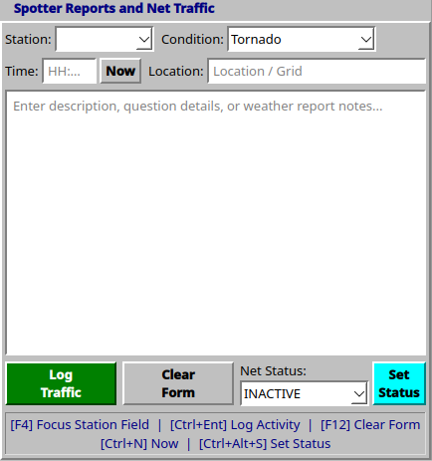

Subzone One – Traffic/Report Details

- Station field (F4) – allows selecting checked-in stations as traffic or report source
- Condition field – allows selecting report or traffic type. These are customizable from the profile editor.
- Time field (Ctrl+N for Now) – time traffic was generated
- Location field – allows location of report to be set
- Details field – allows operator to enter details for the traffic or report

Subzone Two – Controls

- Log Traffic (Ctrl+Enter) – sends traffic or report as entered to the activity log
- Clear Form (F12) – clears form
- Net Status dropdown – allows selection of net status allowable by the profile (this functionality is selectable from the profile editor)
- Set Status (Ctrl+Alt+S) – sets on-air net status according to the dropdown
- Hotkeys legend

Zone Four – Net Traffic (Non-Skywarn)

Net control operators can enter net traffic to the activity log from this pane. It is split into two sub-zones: traffic details and control bar. There are hotkeys assigned to the various functions to allow mouseless operation, such as in deployments where portable, space-saving operations render carrying a mouse unusable.

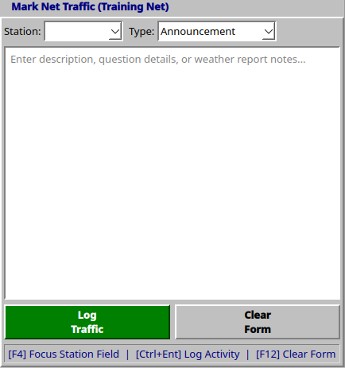

Subzone One – Traffic Details

- Station field (F4) – allows selecting checked-in stations as traffic source
- Type field – allows selecting traffic type. These are customizable from the profile editor.
- Details field – allows operator to enter details for the traffic
Subzone Two – Controls

- Log Traffic (Ctrl+Enter) – sends traffic as entered to the activity log
- Clear Form (F12) – clears form
- Hotkeys legend

Zone Five – Activity Log (Skywarn)

Net control operators can view and manipulate traffic and storm reports entered here. It is split into two sub-zones: live log and controls bar. There are hotkeys assigned to the various functions to allow mouseless operation, such as in deployments where portable, space-saving operations render carrying a mouse unusable.

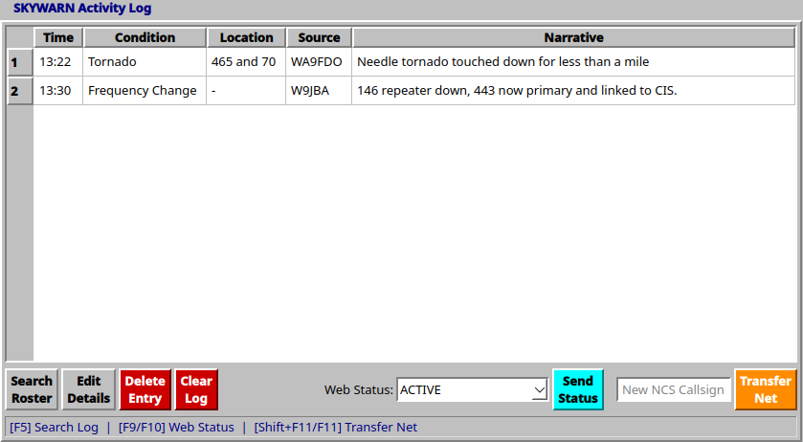

Subzone One – Live Log

As traffic or reports are entered into the log, they will appear here. Displayed data includes time of occurrence, condition or what happened, location, source of traffic or report, and a narrative.

Subzone Two – Controls

- Search Log (F5) – searches for a report by callsign, then highlights it in the log
- Edit Details (Ctrl+Shift+E) – edits narrative
- Delete Entry (Ctrl+Delete) – prompts operator to confirm, then deletes entry
- Clear Log – prompts a user to confirm, then deletes all entries from the log
- Web status dropdown (F9) – allows a user to select a web status to push to their website. These are customizable in the profile editor.
- Send Status (F10) – pushes selected status to the web. Note that this button and the status dropdown are only visible if the profile selected has website interfacing enabled. Currently this is restricted to Marion County, IN ARES.
- New NCS Callsign (Shift+F11) – allows a new NCS callsign to be entered if net is being transferred
- Transfer Net (F11) – logs net transfer and updates net control badge in the status bar

Zone Five – Activity Log (non-Skywarn)

Net control operators can view and manipulate traffic entered here. It is split into two sub-zones: live log and controls bar. There are hotkeys assigned to the various functions to allow mouseless operation, such as in deployments where portable, space-saving operations render carrying a mouse unusable.

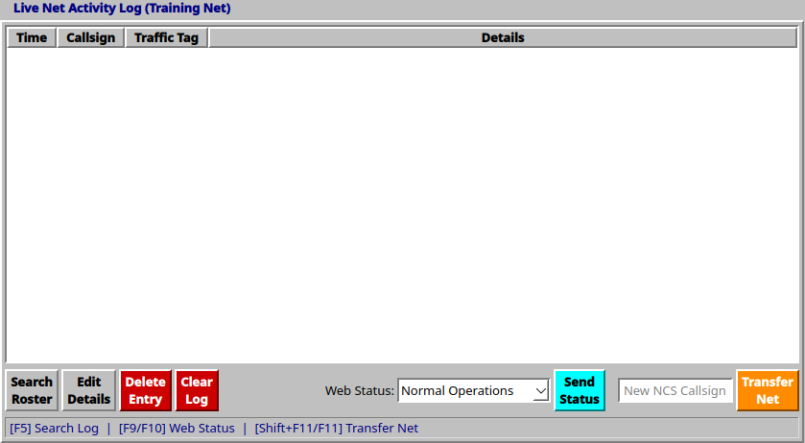

Subzone One – Live Log

As traffic or reports are entered into the log, they will appear here. Displayed data includes time of traffic, callsign of submitting station, type of traffic, and details of traffic.

Subzone Two – Controls

- Search Log (F5) – searches for a report by callsign, then highlights it in the log
- Edit Details (Ctrl+Shift+E) – edits details
- Delete Entry (Ctrl+Delete) – prompts operator to confirm, then deletes entry
- Clear Log – prompts a user to confirm, then deletes all entries from the log
- Web status dropdown (F9) – allows a user to select a web status to push to their website. These are customizable in the profile editor.
- Send Status (F10) – pushes selected status to the web. Note that this button and the status dropdown are only visible if the profile selected has website interfacing enabled. Currently this is restricted to Marion County, IN ARES.
- New NCS Callsign (Shift+F11) – allows a new NCS callsign to be entered if net is being transferred
- Transfer Net (F11) – logs net transfer and updates net control badge in the status bar

Zone Six – Parent Controls

Net control operators can perform certain program-related tasks from here. Certain functions have hotkeys to aid in operation when a mouse is untenable.

- Save Session (Ctrl+S) – saves the current session in case of program malfunction or sudden power loss
- Restore Session – restores a session from autosave
- Hotkeys legend
- Export CSV and Export PDF – exports a net report in either CSV or PDF formats
- Reset Net (Ctrl+R) – prompts user for confirmation, then erases all station check-ins and traffic log entries, resets the online (if applicable) and offline net statuses to their default states, closes any active net, and resets the ID timer to 10 minutes
- Exit App – exits the program

Continued on next page
Section Four – Profile Editor

Net control stations or other ARES personnel are able to enter different profiles for use by their organizations. These profiles are stored in JSON format in the program’s parent directory. There are no hotkeys associated with the profile editor, as profiles must be finalized prior to operational use. It is split into seven zones: general net configuration, station types, traffic/condition types, on-air net statuses with color mapping, API sync (currently restricted to Marion County, IN ARES), net script management, and profile save controls. It is entered from the main screen by pressing F7.

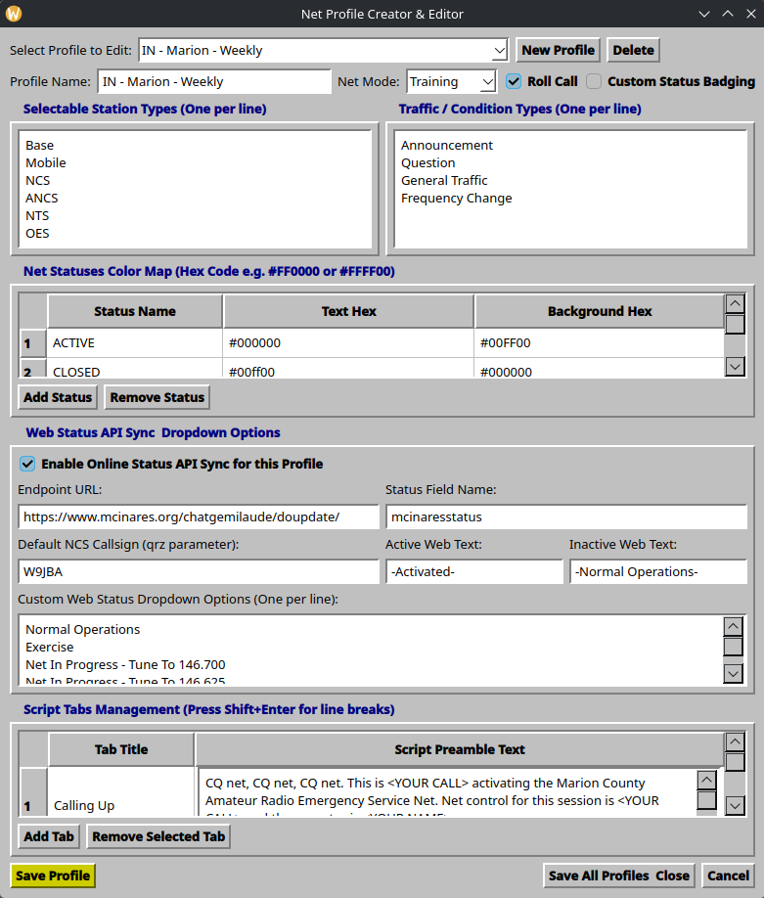
Zone One – General Net Configuration

This allows net profiles to be selected for editing, created, or deleted. Net mode, roll call capability, and custom status badging are also selected from here.

- Profile Dropdown – selects a profile to edit
- New Profile – shows a screen to enter a new profile name, which then allows customizing the new profile
- Delete – deletes the selected profile
- Profile Name – allows editing of a profile name
- Net Mode – selects the net type from the following: regular, SKYWARN, traffic, training, resource, or emergency
- Roll Call checkbox – enables roll call functionality on the station management zone
- Custom Status Badging – controls offline status badging functionality. The program, by default, includes INACTIVE, ACTIVE, and CLOSED. Checking this box allows more statuses to be entered.

Zone Two – User Management

This allows a profile to be locked for use by approved net control stations only.

- Require Passcode – selecting this locks the profile for use by authorized stations, and shows the User Management button.
- User Management – opens the user management screen. This screen is divided into two sub-zones: user entry and controls. The screenshot is presented on the following page.

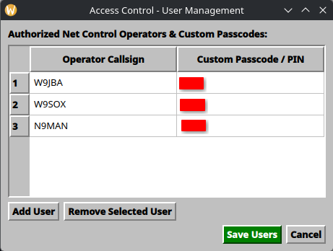

Subzone One – User Entry

Each row is a discrete user. The table is separated into two columns: approved net control operators and their passcode. The passcode can be anything, and there are no special character requirements.

Subzone Two – Controls

- Add User – adds a new user row
- Remove Selected User – removes a user
- Save Users – saves all users currently entered into the manager
- Cancel – closes window and discards changes. There is no confirmation prompt.

Zone Three – Station Types

This zone allows editing of the selectable station types in the station management pane. Unlimited types are allowed but must be on their own line.

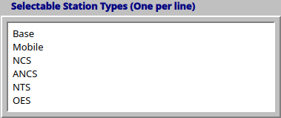

Continued on next page
Zone Four – Traffic / Condition Types

This zone allows editing of the selectable net traffic or storm report types in the Net Traffic pane. Unlimited types are allowed but must be on their own line.

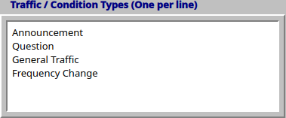

Zone Five – Net Statuses Color Map

This zone allows editing of net statuses if the Custom Status Badging checkbox is enabled. It is split into three columns: status name, hex color of foreground text, and text background hex color.

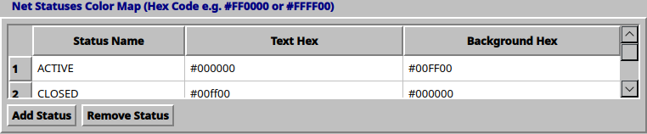

- Add Status – adds a status row
- Remove Status – removes selected status row

Note that this zone expands if the online API function is not selected.

Continued on next page
Zone Six – Web Status API Sync (RESTRICTED TO MARION COUNTY, IN ARES)

This zone allows web URL, field names, and ARES and Skywarn status text to be edited for Marion County, IN ARES. No other ARES organizations are supported at this time.

- Enable Online Status Sync – for Marion County, IN operations, this allows a net to toggle the online status indicators.
- Configure – allows configuration of the API for posting custom net statuses to the Web. This button is hidden if the checkbox is deselected. The resulting screen is divided into two sub-zones: API configuration and controls.

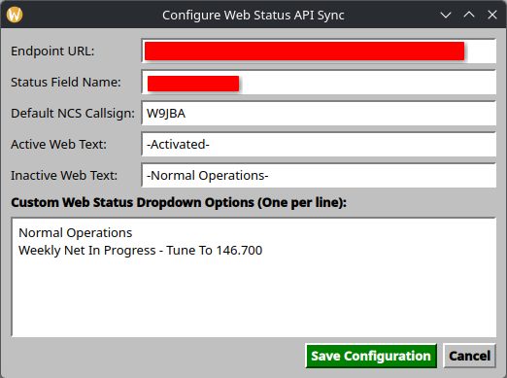

Subzone One – API Configuration

These fields allow entering the requisite information for Marion County, IN ARES API operation.

Subzone Two – Controls

- Save Configuration – saves API configuration
- Cancel – closes the configuration window and discards changes

Zone Seven – Script Management

This zone allows scripts to be edited. There are two columns: tab title and script text. Tab titles do not support multiple lines, but pressing Shift+Enter in a text cell will trigger a line break.

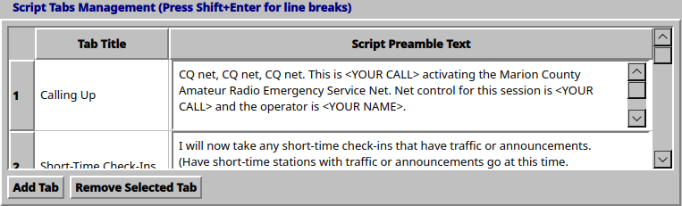

- Add Tab – adds a new tab row
- Remove Selected Tab – removes selected tab row

Zone Eight – Profile Save Controls

These controls allow an individual profile to be saved, all profiles to be saved, or the editor to be closed.

- Save Profile – saves the profile being edited
- Save All Profiles and Close – saves all profiles and closes out the profile editor
- Cancel – closes the profile editor

